Date: ______________ Pt # __
Medical Risk Factors Questionnaire/Interview (4a)
In Person, By Phone, Office, Hospital, Nursing Home, By Relative
(Circle Appropriately)
Interviewer: RM BH LG SZ WA KS JB BB MM

To discover the possible causes and treatment of your jaw problem, we need the following questions answered. Please fill in the blanks and circle the answers that apply best to you. Most questions prompt a “yes” or “no”. If you don’t know an answer, we encourage you to seek help from a family member or your doctor. If you still can’t answer the question place a “?” mark in the margin.

Possible Exclusions:
- If you a history of radiation to head, neck or jaw, do not proceed. You do not qualify for this study.

- Do you have a history of severe traumatic injury within
the last 4 weeks? Yes* No
What Date? ____/____/_______ What kind of injury? _____________

- Do you have a history of major surgery, requiring general
anesthesia within the last 4 weeks?? Yes* No
What kind of surgery? ______________________
How many days were you hospitalized? ________
When were you discharged? ___/___/_____

*These patients will be reconsidered for inclusion into this study 4 weeks after their discharge.

- Do you have a history of bleeding in last 4 weeks? Yes** No
Circle the source of bleeding?
Gastric ulcer Duodenal ulcer Gastritis (lining of stomach)
Colon Polyp nose bleeding, requiring nasal packing Unknown
Other _______________
Were you hospitalized? Yes No
If Yes, where were you hospitalized? ____________
What Date? ___/___/_____
How were you treated? _________________________________
Name of Doctor taking care of you: _______________________
Approximately what date did bleeding stop? ___/___/_____
Do/did you have black stools? Yes No
When ____/___/________
Did you go to your primary care doctor for evaluation? Yes No
What tests did the doctor order? ___________________________
Name of the doctor that treated you: _______________________

**Patients should be asked to return 4 weeks after their bleeding has stopped, for reconsideration into the study.

A. Lifestyle Risk Factors:

- What is your age?
30-40 years old Yes No
41-60 years old Yes No
61-72 years old Yes No
73-99 years old Yes No
older than 100 years old Yes No

- Circle your ancestry(s): African Middle Eastern Indian Latino
Asian Native American European

- Did you circle European ancestry? Yes No

- Are you female? Yes No

- Are you on one of the following diets? Yes No
Circle which one(s):
high sugar Atkins Paleo fast food

- What is your activity level? Are you one of the following? Yes No
wheelchair bound bedridden sedentary

- Do you or did you smoke? Yes No
Did you start smoking before the age of 18? Yes No
Did you start smoking after the age of 18? Yes No
How much did you smoke?
1- 2 packs per day Yes No
more than 2 packs per day Yes No
“Pack years” = # of packs smoked/ day x # of years smoked
less 15 pack years Yes No
more than 15 pack years Yes No

- Do you drink alcohol regularly? Yes No
More than 3 drinks/day? Yes No
Are you an alcoholic? Yes No
Do you have cirrhosis of liver? Yes No

- Have you have ever weighed more than 280 pounds? Yes No

- Have you had surgery for weight loss? Yes No

- Have you ever had major surgery, requiring anesthesia? Yes No

- Have you been hospitalized for a medical problem
in the last 5 years? Yes No

- What is your height? _____ft. _____in. What is your weight in pounds? _______

- Refer to chart to estimate the Body Mass Index (BMI)
Patient’s BMI =_______
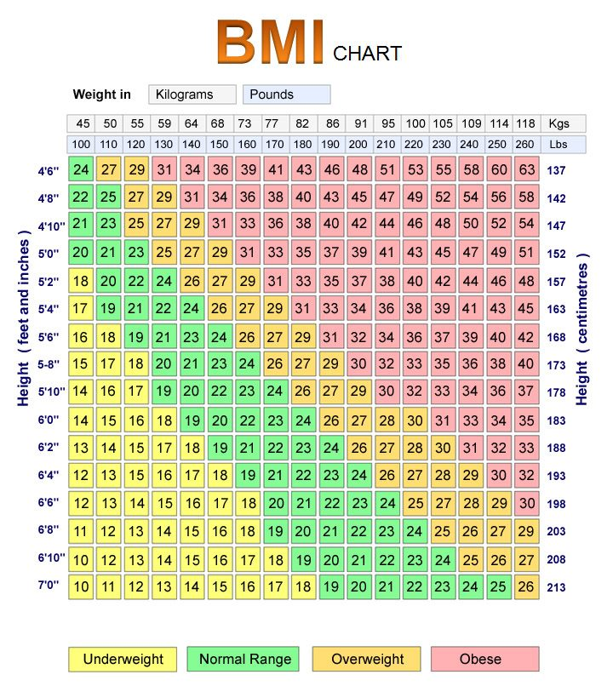
- Are you underweight (i.e. BMI less than 18)? Yes No
- Are you obese (i.e. BMI is 35 or greater)? Yes No
- Has your weight ever been greater than 100lbs over your ideal weight? Yes No
Your ideal weight can be estimated by using your height on the left side of the BMI chart and check what green boxes correspond to your height. Pick the middle one or two green boxes. Check what weights these boxes correspond to. Weights are listed at the top of the chart, by looking on the vertical axis portion of the BMI section. Your ideal weight will be an average of the weights listed for your height.

Patient’s Score /Maximum Score Possible [ /20]

B. Blood Clots/Coagulopathy:

- Do you have a family history of blood clots? Yes No

- Do you have a history of blood clots? Yes No

Circle location of clot(s):
legs lungs brain/stroke abdomen other __________

Were the clots in the arteries? Yes No
Were the clots in the veins? Yes No

- Are you or were you on blood thinners? Yes No

- Have you been treated with “clot busters?” Yes No Circle location of clot(s): brain leg lung abdomen other

- Are you or were you on any of the following medications? Yes No Circle which one(s) you are or were on:
aspirin Plavix/clopidogrel Coumadin/warfarin Xarelto/rivaroxaban Heparin Lovenox/enoxaparin Angiomax/bivalirudin Argatroban TPA
Other(s) ______

- Are you on any other blood thinners? Yes No
Which ones? ________________________________________________________
________________________________________________________________________
________________________________________________________________________

- Were you treated with more than one of the above medications? Yes No

- Were you treated with more than three of the above medications? Yes No

- Were you treated with more than four of the above medications? Yes No

- Why were you treated with this/ these medication(s)? ______________________

- Have you ever been told that you had Antiphospholipid
Antibody or Syndrome ? Yes No

Patient’s Score /Maximum Score Possible [ /11]

C. OB-GYN:

- Have you have ever taken any of the following medications:
Birth Control medication: pills patches shots? Yes No
Were you on them from 1-3 years? Yes No
Were you on them from 4-6 years? Yes No
Were you on them from 7-10 years? Yes No
Were you on them more than 10 years? Yes No
Did you start taking them before the age of 18? Yes No
Did you start taking them after the age of 18? Yes No

- Have you have ever received fertility shots? Yes No
Were you on them less 1 year? Yes No
Were you on them from 1-2 years? Yes No
Were you on them from 2-3 years? Yes No
Were you on them greater than 4 years? Yes No

- Have you had: 3 or more children? Yes No
More than 2 miscarriages? Yes No
More than 2 abortions? Yes No

- Have you ever taken post-menopausal estrogen such as Premarin? Yes No
Were you on them from 1-3 years? Yes No
Were you on them from 4-6 years? Yes No
Were you on them from 7-10 years? Yes No
Were you on them more than 10 years? Yes No

Patient’s Score /Maximum Score Possible [ /10]

D. Inflammatory Diseases:

- Do you have arthritis? Yes No
Do you have Rheumatoid Arthritis Yes No
Do you have Psoriatic Arthritis Yes No
Do you have Ankylosing Spondylitis Yes No

- What medications were used to treat your arthritis?
Corticosteroids Yes No
Methotrexate Yes No
Humira Yes No
Other(s) ____________________ Yes No

Were you treated with any one of the above medications
for more than 6 months? Yes No

Were you treated with more than one of the above
medications for greater than 6 months? Yes No

- Do you have any of the following disorders?
Lupus Erythematosus Yes No
Inflammatory Bowel Disease Yes No
What medications were used to treat the above diagnoses?
Corticosteroids Yes No
Methotrexate Yes No
Humira Yes No
Other(s) ____________________ Yes No

Were you treated with any one of the above
medications for more than 6 months? Yes No

Were you treated with more than one of the above
medications for greater than 6 months? Yes No

Patient’s Score /Maximum Score Possible [ /18]

E. Endocrine:

- Do you have Diabetes? Yes No

- If yes, what kind do you or did you have?
Diabetes Mellitus, Type 2- Diet Control Yes No
Diabetes Mellitus, Type 2-Diet & Med Control Yes No
Diabetes Type 2- Insulin Dependent Yes No
Diabetes- Type 1 Yes No

- How long have you had Diabetes Mellitus?
from 4-6 years Yes No
from 7-10 years Yes No
from 11-15 years Yes No
from 16-20 years Yes No
Greater than 21 years Yes No

- Have you ever had a low thyroid condition that was untreated? Yes No

- Have you taken medications for hyperthyroidism,
specifically propylthiouracil (PTU)? Yes No

- Have you taken Radioactive Iodine for hyperthyroidism? Yes No

- Do you have a history of any of the following adrenal
gland dysfunction? Cushing Syndrome Addison’s Disease Yes No

- Have you ever had a pituitary tumor? Yes No

- Have you ever had a parathyroid tumor ? Yes No

Patient’s Score /Maximum Score Possible: [ /10]

F. Cardiac:

- Do you have a history of high blood pressure? Yes No

- Do you have a family history of premature heart attacks or
sudden death (earlier than 50 years of age)? Yes No

- Do you have history of a heart attack(s)? Yes No

- Have you had more than one heart attack? Yes No

- Have you ever had a coronary balloon angioplasty or stent(s)? Yes No

- Have you had more than one balloon angioplasty or stent(s)? Yes No

- Have you had between 3 and 5 balloon angioplasties or stents? Yes No

- Do you have angina (chest pain or arm pain with exercise)? Yes No
How long have you had it?
between 1-3 years Yes No
between 4-5 years Yes No
more than 5 years Yes No

- Have you ever had heart surgery? Yes No
Have you had more than one surgery? Yes No
What kind of surgery did you have?
coronary Artery Bypass Graft (CABG) Yes No
heart valve surgery Yes No
other __________ Yes No

- Have you ever had congestive heart failure? Yes No
How long have you had it?
between 1-3 years Yes No
between 4-5 years Yes No
more than 5 years Yes No

- Do you have swelling of the legs? Yes No
How long have you had it?
between 1-3 years Yes No
between 4-5 years Yes No
more than 5 years Yes No

Patient’s Score /Maximum Score Possible [ /18]

G. Vascular/Lipids:

- Do you have disease of the carotid arteries in the neck? Yes No
How severe? _____%

- Do you have an abdominal aortic aneurysm? Yes No
How large?________cm

- Do you high total cholesterol? Yes No
Is it 240 mg/dl or greater (severe risk)? Yes No

- Do you have high LDL cholesterol i.e. “bad” cholesterol? Yes No
Is it greater than 160 mg/dl? Yes No

- Do you have low HDL level i.e. “good” cholesterol? Yes No
Is it less than 40mg/dl? Yes No

- Do you have high triglyceride level? Yes No
Is is 500mg% or greater? Yes No

- Are you being treated for a cholesterol/ lipid problem? Yes No

- Are you taking a “statin” medication? Yes No

Examples of statin medications are below. Are you taking?
Mevacor/lovastatin Yes No
Lipitor/atorvastatin Yes No
Pravachol/pravastatin Yes No
Zocor/simvastatin Yes No
Other(s) _________ Yes No

Have you taken a “statin” medication?
between 1-3 years Yes No
between 4-5 years Yes No
more than 5 years Yes No

- Do you have metabolic syndrome? Yes No

Metabolic syndrome is the combination of high blood pressure, high blood sugar, too much fat around the waist, low HDL ("good") cholesterol, and high triglycerides. Metabolic syndrome increases your risk for heart disease, diabetes, and stroke.

[Lipid Information]

  - Ideal total cholesterol < 200 mg/dL
moderate risk: 200-239 mg/dL
severe risk : 240 or >severe risk

  - Near optimal level: 100- 129
Borderline LDL: 130-159
High LDL: 160-199
Very high LDL >200

  - Ideal triglyceride is < than 150mg/dL [0
Borderline high triglycerides=150-199 [2]
High: 200-499[3]
Very high triglycerides: = or > 500mg [3]

  - Ideal HDL/ total Cholesterol: (The lower the ratio, the higher the risk of a heart attack)
If ratio 0.24 or higher (0 point)
If ratio is under 0.24- low (1 point)
If ratio is less than 0.10- very dangerous [3points]

  - Ideal triglyceride/ HDL Cholesterol: (The higher the ratio, the higher the risk of heart attack)
If the ratio is 2 or less- considered ideal [0 point]
If ratio is 4- high [2 points]
If ratio is 6- much too high [3 points]
These patients also tend to have high levels of clotting factors.

Patient score /Maximum Score Possible: [ /19]

H. Chronic Diseases:

- Do you have any of the following systemic diseases?
End stage kidney disease / Hemodialysis Yes No
Anemia (severe) Yes No
HIV infection Yes No
Hepatitis Yes No

- Do you have any of the following pulmonary diseases?
asthma Yes No
severe COPD/emphysema Yes No
pulmonary fibrosis Yes No
pulmonary hypertension Yes No

Patient’s Score /Maximal Score Possible: [ /8]

List all mediations you are taking:

Total Medical risk factors score/ Maximum score possible: [ /114]

